

COAL STOCKPILE MODELLING WITH PREDICTIVE MACHINE LEARNING
A Decision Support Tool utilising the Predictive Capabilities of Machine Learning Technology



Table of Contents
1. Introduction 4
1.1 Purpose 4
1.2 Scope 4
1.3 Definitions and Acronyms 4
1.4 Problem Definition 5
2. Functional Requirements 6
2.1 System Overview 6
2.2 Detailed Functional Requirements 6
Planning & Insights Analysis 6
Scenario Simulation & Management 7
Model Health Tracking 7
Historical Data Visualisation 7
AI Report Generation 8
User Access Control 8
2.3 User Stories 8
2.4 User Interface Requirements 10
3. Non-functional Requirements 18
3.1 Performance 18
3.2 Reliability 18
3.3 Security 18
3.4 Usability 18
3.5 Scalability 19
4. Data Requirements 20
4.1 Data Sources 20
4.2 Data Types and Formats 21
4.3 Data Volume 21
5. System Integration Requirements 23
5.1 Data Source Systems Integration 23
5.2 Deployment Requirements 23
5.2.1 Deployment Environment 23
5.2.2 Continuous Integration/Continuous Deployment (CI/CD) Pipeline 23
6. Preprocessing Requirements 25
6.1. Handling Missing Values 25
6.2. Data Transformation 25
6.3. Feature Engineering 26
6.4. Data Quality Checks 27
6.5. Pipeline Automation and Reproducibility 27
7. Model Requirements 28
7.1 Modelling Approach 28
7.2 Type of Machine Learning Models and Training Frequency 29
7.3 Performance Metrics 31
7.4 Retraining Triggers 31
7.5 Explainability Requirements 32
8. Monitoring and Maintenance Requirements 34
8.1 Model Monitoring 34
8.2 Logging and Alerting 34
8.3 Post-Deployment Maintenance 35
9. Usability Requirements 37
9.1 User Training and Documentation 37

1. Introduction

1.1 Purpose
The purpose of this Functional Requirements Specification Document (FRSD) is to outline the technical aims, requirements, and expectations for the Coal Stockpile Modelling with Predictive Machine Learning Project, commissioned by Eskom. This document provides a comprehensive foundation for developing and implementing a machine learning model designed to accurately forecast coal stockpile levels. It specifies the data requirements, model design, and integration needs to ensure that the machine learning solution achieves the necessary accuracy, reliability, and scalability to support Eskom’s coal stock management.

1.2 Scope
This Functional Requirements Specification Document details the technical scope of the Coal Stockpile Modelling with Predictive Machine Learning Project, covering:
- Project Overview: A description of the project’s objectives, including technical requirements for achieving predictive accuracy and model robustness.
- Functional Requirements: Precise specifications for the model’s functionalities, including data preprocessing, prediction capabilities, feature importance analysis, and scenario simulations.
- Non-Functional Requirements: Specifications for performance, reliability, security, usability, and scalability to ensure the model meets operational standards and technical expectations.
- Data Requirements: Detailed requirements for data sources, types, quality, and preprocessing steps essential for building and maintaining a reliable machine learning model.
- Integration Requirements: Technical integration points with Eskom’s existing systems and external data services, covering necessary interfaces, data flow mechanisms, and deployment configurations.
- Exclusions: Specific functionalities or features, such as potential future integrations or advanced analytics modules, that are beyond the scope of the current phase of the project.

1.3 Definitions and Acronyms
- Machine Learning (ML): A branch of artificial intelligence that enables systems to learn from data and make predictions or decisions.
- Stockpiling: The process of accumulating and managing inventory (in this case coal) to ensure consistent supply.
- Horizontal Scaling: Adding more servers or nodes to a system to manage increased load.
- Vertical Scaling: Increasing the capacity of existing servers by adding more resources like CPU, RAM, or storage.
- Model accuracy: Model accuracy for regression tasks refers to how well a regression model's predictions match the actual values of the target variable.

1.4 Problem Definition
Eskom operates multiple coal-fired power stations to generate electricity for the country. These stations depend on a continuous supply of coal, which can either be fed directly to the power station units or stockpiled at designated coal stockyards. Coal stockpiles are essential to maintain continuous operations, especially when coal supply to a station is temporarily interrupted. Eskom’s Primary Energy Department (PED) is responsible for planning, procuring, and delivering coal to these power stations. Currently, PED relies on a static model to estimate coal stock levels, but this model lacks the ability to account for the complexities of the coal supply chain, external factors, individual characteristics of each power station, and inter-station dynamics.
The current static model calculates coal stock levels using a basic formula: Closing Stock = Opening Stock + Supply - Burn. However, this approach is limited as it fails to incorporate critical external factors, such as weather conditions, inter-station dynamics, and market dynamics like coal prices, exchange rates, and crude oil prices. To address these limitations, a machine learning model is proposed. This model aims to accurately forecast coal stock levels at each power station by accounting for multiple dynamic and interdependent variables. By overcoming the constraints of the existing static model, the machine learning model will provide actionable insights, enabling more effective coal stockpile management and improved decision-making.

2. Functional Requirements

2.1 System Overview
The Machine Learning (ML) solution for Eskom’s coal stock management is designed to enhance coal inventory forecasting, improve decision-making, and ensure consistent coal supply across power stations. By leveraging predictive modelling, trend analysis, scenario simulations, and advanced data visualization, the system will empower planners to proactively manage coal stock levels and respond to supply chain dynamics. The system also includes user access control to secure data and limit access according to role-based permissions.

2.2 Detailed Functional Requirements

Planning & Insights Analysis

Predictive Modelling
The ML solution will provide the following predictive models for each of the power stations in Eskom’s coal fleet:
Model | Function | Specifications | Input Requirements | Output Format
Coal Supply | Accurately forecast monthly coal supply quantities for each power station. | - Predictions should include confidence intervals and be updated with new data to improve forecasting accuracy.  - The model should account for underlying patterns and integrate historical seasonal trends. | Coal supply data, historical delivery patterns, and external factors (e.g., weather, economic conditions). | Monthly coal supply forecasts with a 95% confidence interval for each power station.
Coal Burn | Forecast monthly coal burn for each power station. | - Predictions should include confidence intervals and be updated with new data to improve forecasting accuracy.  - The model should account for underlying patterns and integrate historical seasonal trends. | Coal burn data, historical coal burns, power station operational factors, and planned coal burn. | Monthly coal burn predictions with a 95% confidence interval.
Coal Stockpile Levels | Forecast coal stockpile levels or range for each power station based on supply and coal burn patterns. | Provide upper and lower bounds on stockpile levels to account for variability in supply and coal burn. | Coal supply and burn forecasts, current stockpile levels. | Monthly stockpile level predictions with bounds to reflect variability.

Forecast Drivers Analysis
- Function: Identify and provide insights into variables driving coal supply, coal burn, and stockpile levels.
- Specifications:
  - Variables will be ranked by their net contribution to the coal stockpile level forecasts, and insights will be updated periodically or during model retraining.
  - Key features will be presented alongside explanations for their impact on stockpile level predictions.
- Output: Visualisations of top features influencing forecasted coal stock levels, their net contributions to the generated forecasts, and their accompanying explanations.

Scenario Simulation & Management
- Function: Enable users to create and manage simulations of different scenarios (e.g. decreased EAF at a power station) to assess the impact of changes in key variables on coal supply, burn and stockpile levels.
- Specifications:
  - Users can input hypothetical values for parameters (e.g., increased energy demand, reduced supply) and view resulting impacts on stock levels.
  - Scenarios should provide variable contribution analysis, illustrating how each parameter change influences outcomes.
  - Users can run and compare multiple scenarios simultaneously.
- User Interactions: Users choose parameters, set ranges for uncertainty, and run simulations.
- Output Format: Summaries of each scenario’s impact on coal stock levels, with forecasted vs. simulated results comparisons.

Model Health Tracking
- Function: Enable users to keep track of the health of the forecasting models, and trigger model retraining if necessary.
- Specifications:
  - Users can view model performance and error scores over time.
  - Users can view and interpret key drift metrics such as concept drift (model losing predictive performance), data drift (changes in the distributions of data used by the model), etc.
  - Users can check the health of the model and data pipelines to determine that the model training and prediction tasks have executed properly.
  - User can trigger model retraining to account for changes in data distributions and decreased predictive power.
- User Interactions: Users can select which machine learning models to analyse, and trigger model retraining.
- Output Format: Visualisations (charts, graphs, etc.) of model performance metrics, shifts in data distributions, model training logs, and changes in performance metrics over time.

Historical Data Visualisation
- Function: Provide visualisations, such as dashboards and charts, for historical coal supply, burn and stockpile levels and trends.
- Specifications:
  - The visualisations should allow for data filtering by time, data source (burn, supply, stockpile level, EAF, PCLF, UCLF, etc.) and power station.
  - Visualisation types include line charts and bar graphs.
- User Interactions: Users can filter, drill down into data, and export visualisations for reporting.
- Output: Visuals displaying coal supply, burn, stockpile levels, trends, etc. for quick, data analysis.

AI Report Generation
- Function: Enable users to create and manage AI-created reports based on coal supply, burn and stockpile level forecasts, and forecast drivers to interpret model outputs and created scenarios.
- Specifications:
  - Users can input hypothetical values for parameters (e.g., increased energy demand, reduced supply) and view resulting impacts on stock levels.
  - Scenarios should provide variable contribution analysis, illustrating how each parameter change influences outcomes.
  - Users can run and compare multiple scenarios simultaneously.
- User Interactions: Users select the models, forecasts, scenario simulations, and drivers to create reports. Users can generate reports/insights via a chatbot interface.
- Output Format: Generated report interpreting model forecasts, scenario simulations, and drivers.

User Access Control
- Function: Ensure data security and control access to features and data based on user roles.
- Specifications:
  - Roles include Admin (full access, user management), Planner (access to scenario analysis, data visualisation), and Viewer (view-only access to dashboards).
  - Access levels will be configurable and controlled by Admins to maintain data security.
  - Role-based permissions should be enforced at all levels, with activity logs for auditing purposes.
- Security Measures: Apply encryption and robust access control with logs of user interactions.

2.3 User Stories
The table below shows the functionalities of the envisioned final product (platform), their tasks and associated user stories.
Functionality | Tasks | User Stories
Landing Page | - Station Selection  - Forecast Window Navigation  - Model Confidence Level | - As a planner, I want to select a power station to view its forecasted coal supply, burn, and stockpile levels.  - As a planner, I want to navigate forecast time windows (e.g., next 31 – 89 days, 1 – 2 years ahead, etc.) to see forward-looking trends.  - As a planner, I want to see forecast confidence levels to understand the certainty of predictions.
Planning Insights & Analytics | - Station Selection  - Forecast Window Navigation  - Forecast Visualisation  - Forecast Driver Analysis | - As a planner, I want to view interactive visuals of forecasted coal supply, burn, and stockpile by station and time frame.  - As a planner, I want to analyse the key drivers influencing forecast results, with ranked variables and explanations of their impact.
Scenario Simulation & Management | - Station Selection  - Forecast Window Navigation  - Forecast Visualisation  - Forecast Driver Analysis  - Simulation Test Case Creation & Management | - As a planner, I want to create simulation scenarios (e.g., lower EAF, increased demand) and see how they affect coal stock levels.  - As a planner, I want to compare multiple scenarios side-by-side to assess resilience.  - As a planner, I want to view contribution analysis for each scenario to understand what drove the simulated outcomes.
Model Health Tracking | - Model Performance Overview (confidence intervals, error scores, execution time, etc.)  - Drift tracking (model drift, data drift, etc.)  - Model and Data Pipeline Health  - Model Management | - As a planner, I want to monitor model performance metrics over time (e.g., error scores, execution lag).  - As a planner, I want to see alerts or visualizations of concept drift or data drift so I know when retraining may be needed.  - As a planner, I want to manually trigger model retraining to restore accuracy after performance degradation.
Data History | - Station Selection  - Data History Visualisation | - As a planner, I want to view historical coal supply, burn, and stockpile trends for selected stations to validate forecasts.  - As a planner, I want to filter historical data by station, variable (EAF, UCLF, stock levels, etc.), and time range for targeted insights.
AI Report Generation | - Report Generation  - Forecast Interpretation | - As a planner, I want to use a chatbot interface to create custom, AI-interpreted reports using specific parameters (e.g., chosen station, timeframe, simulation results).
User Access Control | - Granting user access and roles | - As an admin, I want to assign and manage roles (Admin, Planner, Viewer) to restrict access based on job function.  - As a planner, I want to access simulations, insights, and reports but not modify user roles or backend settings.  - As an auditor, I want logs of user activities for security and accountability.

2.4 User Interface Requirements

Landing & Sign-In Screens



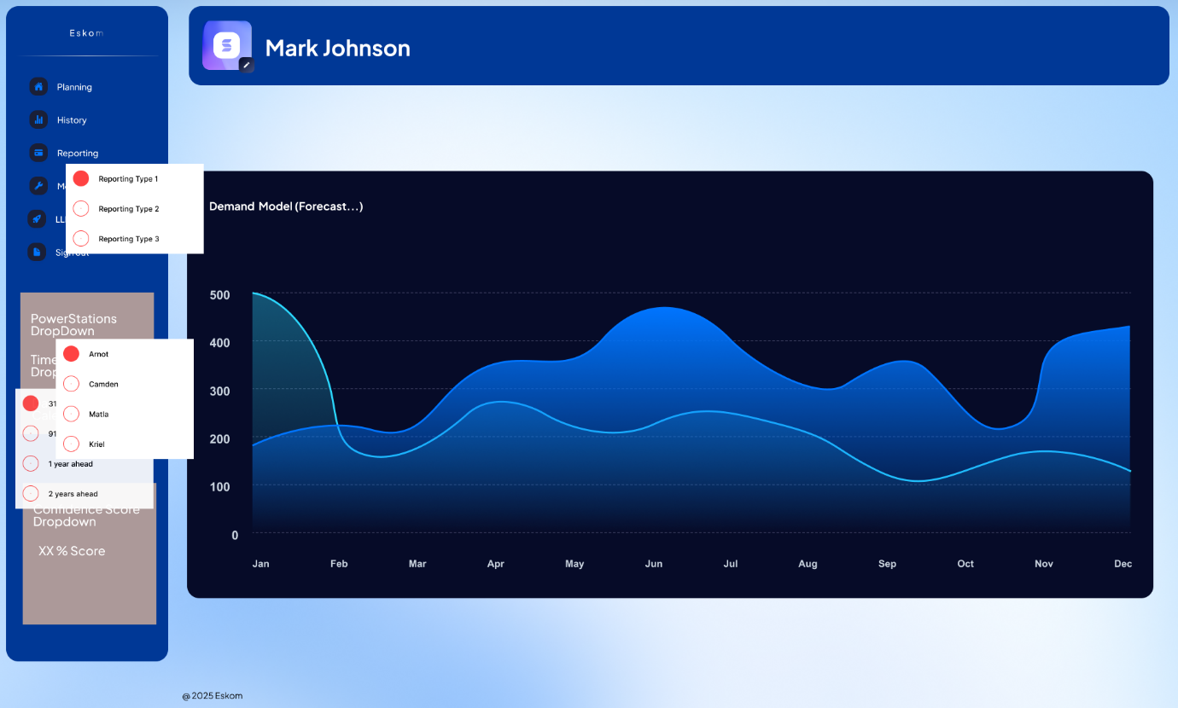
- Visual: Branded welcome page with bold architectural graphic, retaining futuristic style.
- Function:
  - Secure login interface with “Remember me” toggle.
  - Direct links to account registration.
  - Full-width layout split between branding and authentication.

Planning Screen

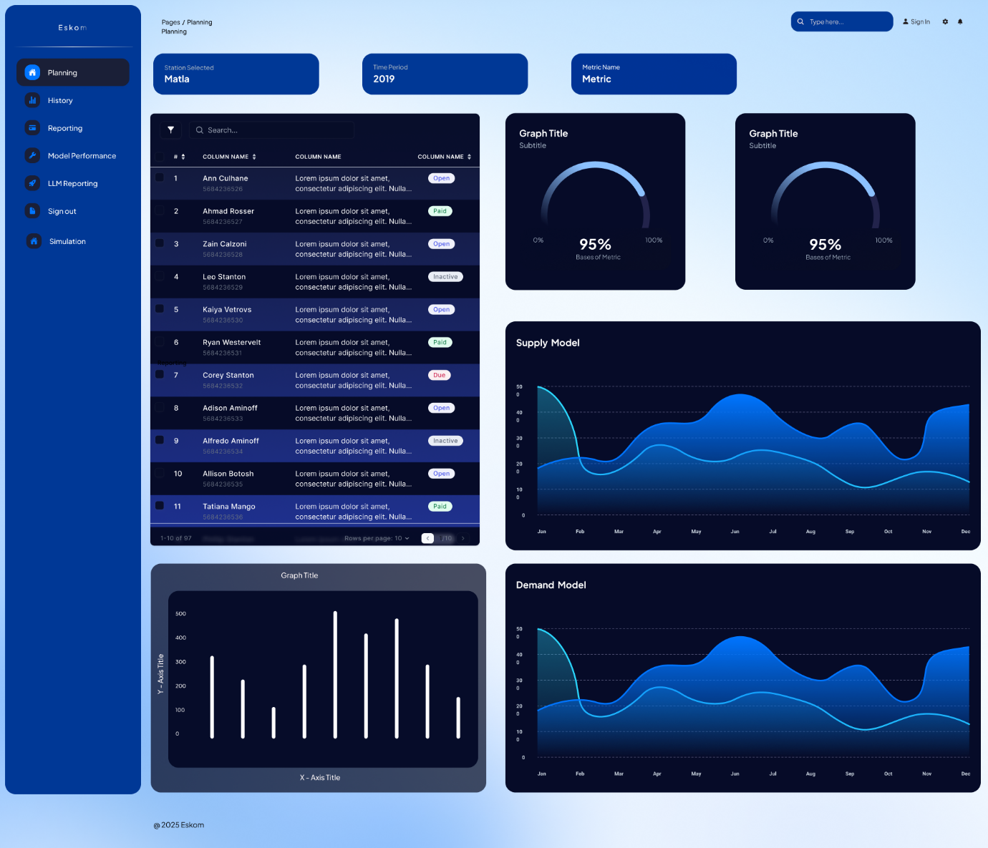
- Station & Metric Selector
- Full Forecasting Dashboard Output:
  - Table of active data
  - Two KPIs
  - Supply Model
  - Demand Model
  - Performance Chart
- Purpose:
- Central planning centre for strategic and operational forecasting review

History Screens (Result Snapshots & Snapshot Details)



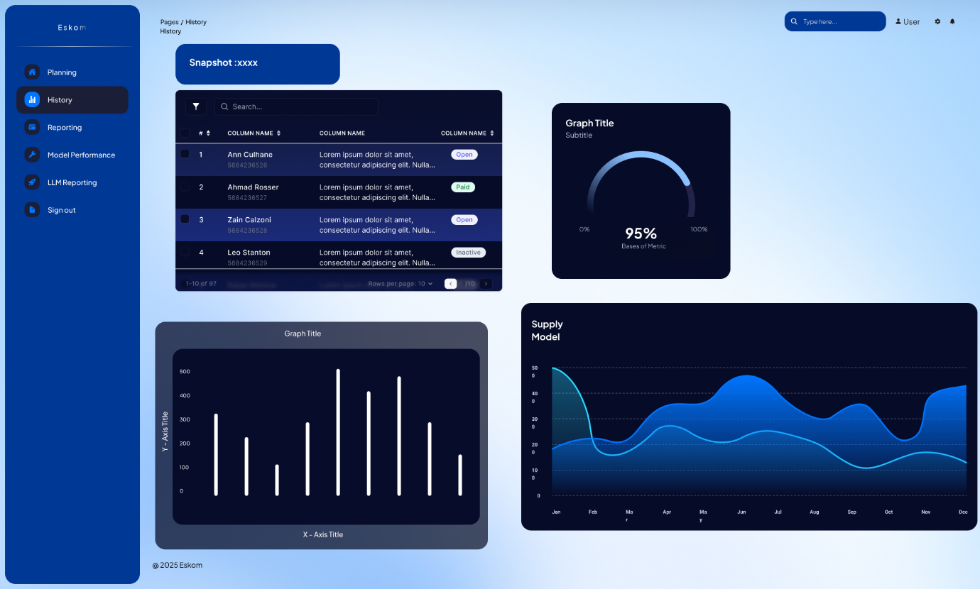
- Snapshot List View:
  - Simplified result log cards with edit/delete actions.
  - Enhanced scan ability for past analytics.
- Snapshot Detail View:
  - Searchable and filterable table of user-specific data.
  - Data tags (e.g. Open, Paid, Inactive) for quick classification.
  - KPI ring graph and Supply Model graph shown alongside bar graph.

LLM Reporting Screen

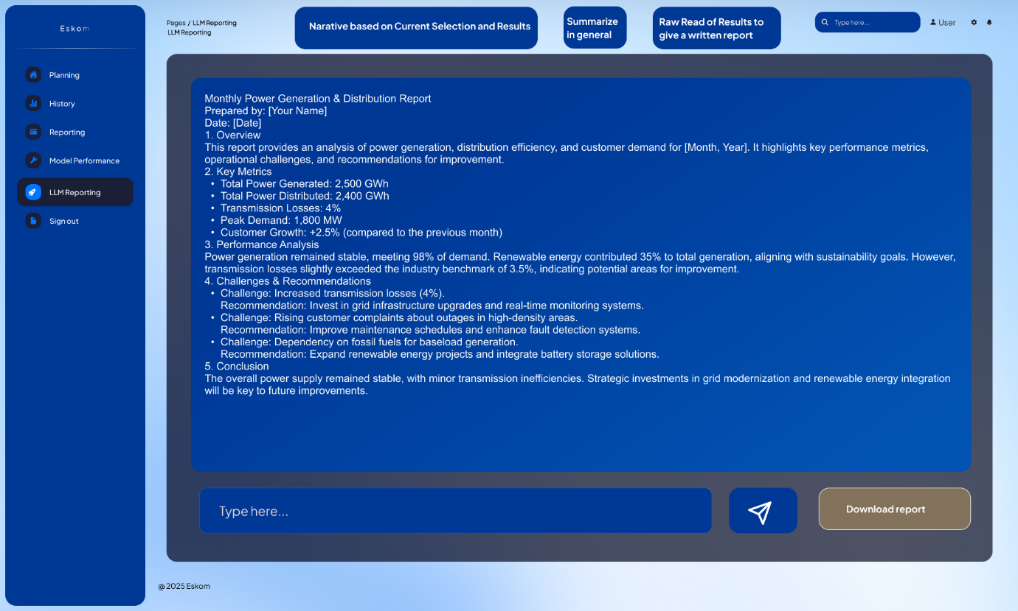
- Content:
  - AI-assisted narrative generation area.
  - Summarisation button options: Narrative, Summary, Raw Report.
  - AI-generated report text box with option to edit or generate new.
  - Downloadable final report in PDF or Word format.
- Functionality:
  - Converts complex metrics into executive-ready narratives using AI.

Model Performance Screen

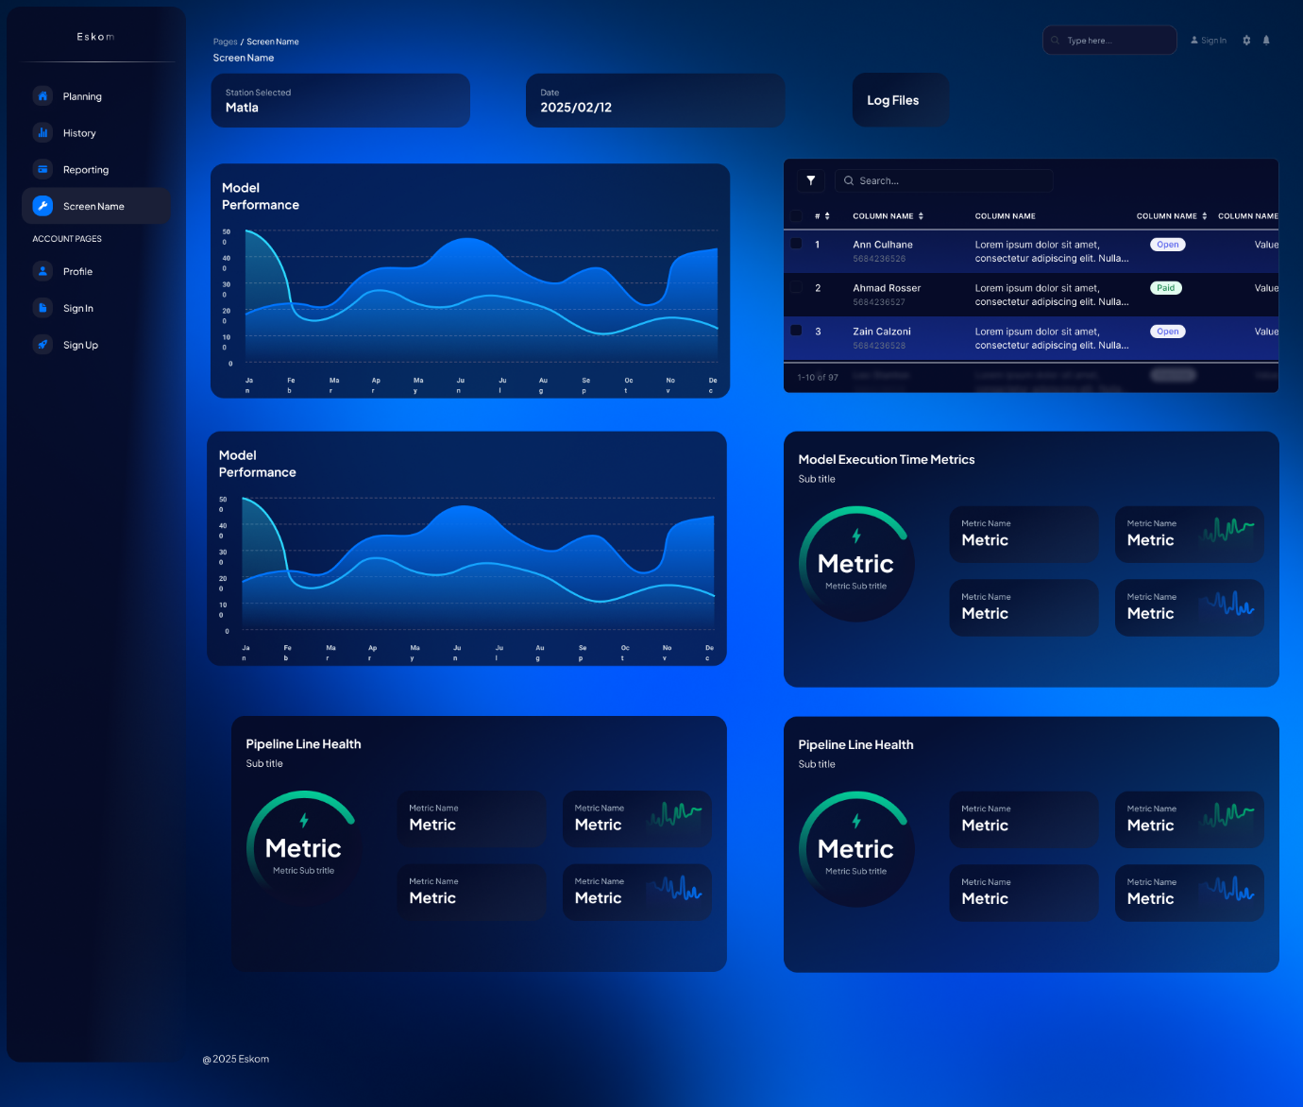
- Sections Included:
  - Model Performance Graphs (trends over time)
  - Forecast Metrics (e.g. % of data used, timeline)
  - Pipeline Health Indicators (status dials, sparkline graphs)
  - Execution Metrics (execution speed, retraining frequency)
  - Data Status Panel (refreshed/next refresh schedule)
- Value Added:
  - Gives engineering and ML stakeholders a quick pulse-check on model lifecycle health and readiness.

Reporting Screen

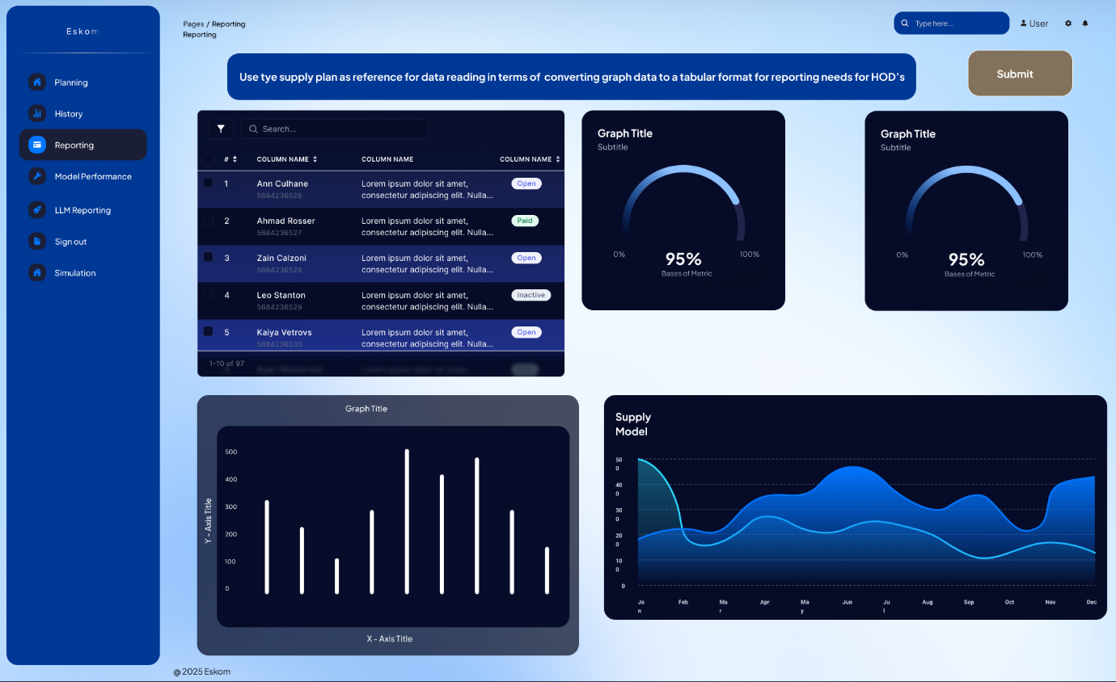
- Table View:
  - Enhanced filterable data view
  - Data status tags retained
- Graphical KPIs:
  - Two radial dial graphs and line chart to present supply modelling visually
- Instructional Banner:
  - Banner guiding users on how to translate graphical insights into tabular reports for HODs.
- Action Button:
  - Submission triggers backend processing/report creation.

Simulation Screen

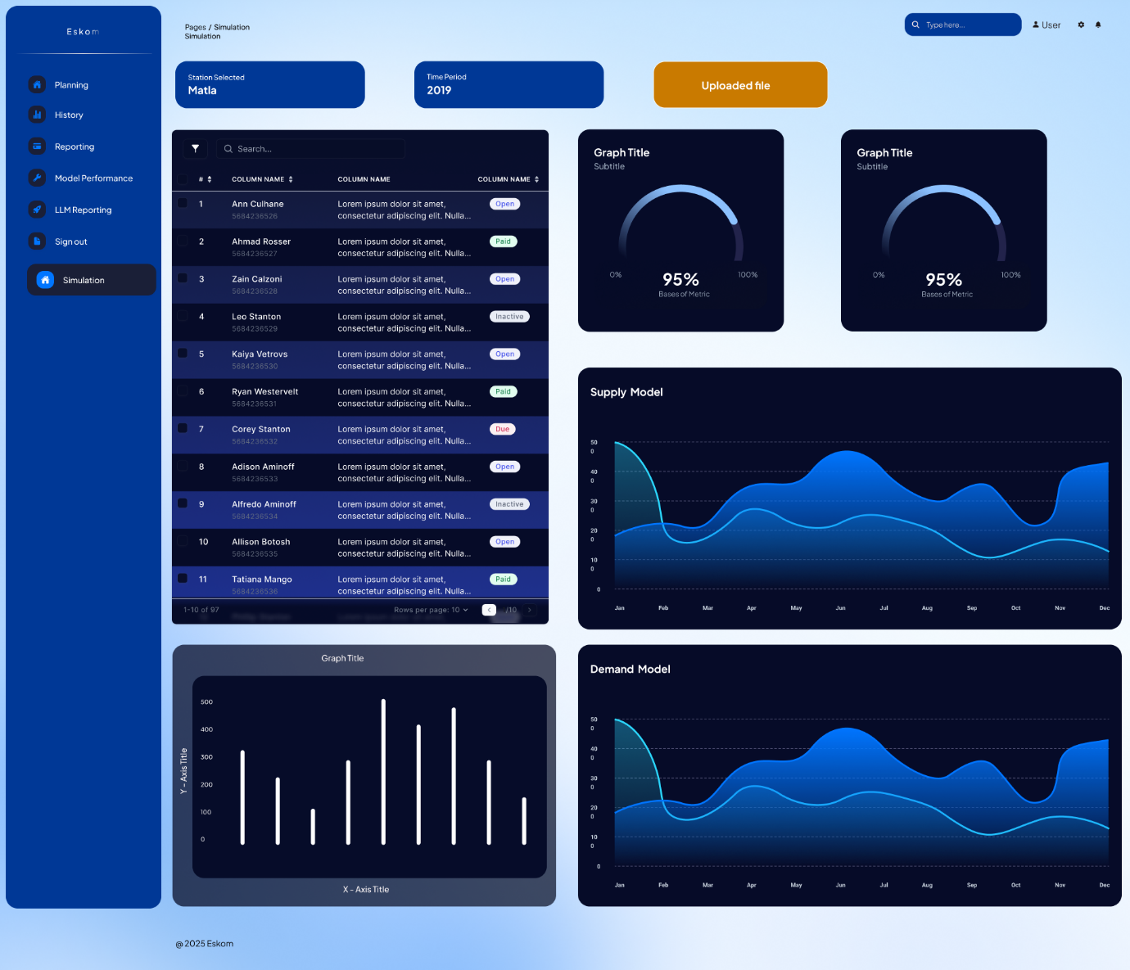
- Filters and Controls:
  - Dropdowns for: Power Station, Forecast Period (e.g., 1 year ahead), Confidence Score
  - Reporting type selector
- Data Grid:
  - Status-tagged rows (e.g. Open, Paid, Inactive, Due)
  - Data table with pagination
- Forecast Output:
  - Dynamic graphs (Demand/Supply Models, Bar Charts, KPIs) update based on simulation selections.
- Upload Logic:
  - Highlighted "Uploaded File" button for initiating input upload for simulation.

By adhering to these functional requirements, the ML solution will support Eskom in enhancing forecast accuracy, enabling proactive stockpile management, and improving decision-making.

3. Non-functional Requirements

3.1 Performance
- Scalability: The system must efficiently manage large volumes of historical data and data from multiple data sources without significant performance degradation.
- Throughput: The system must process and analyse data at a rate that supports continuous monitoring and forecasting.
- Training Frequency: The model must be retrained periodically (e.g., monthly or quarterly) based on data availability and performance metrics. Retraining frequency will be defined based on observed data drift and model accuracy, ensuring predictions remain accurate and relevant.

3.2 Reliability
- Availability: The system must maintain high availability with minimal downtime, supporting Eskom’s planning and operational needs effectively.
- Fault Tolerance: Implement redundancy and failover mechanisms to ensure system functionality during hardware, software, or model-related failures. This includes enabling model rollbacks to previous versions, versioning of models and code scripts, and rollback capabilities for development and execution files to safeguard the machine learning pipeline's integrity.
- Accuracy: The model should maintain a high level of accuracy in its predictions and analyses. Regular validation and updates are necessary to sustain reliability, with automated alerts to trigger retraining if accuracy falls below a pre-defined threshold.
- Model Monitoring: Continuous monitoring of model performance is essential to detect data drift, accuracy changes, and other performance deviations over time. Monitoring metrics, including accuracy, precision, recall, and data drift indicators, will help maintain model integrity. Alerts should be generated if thresholds are breached to initiate review and potential retraining.

3.3 Security
- Data Encryption: All data, both at rest and in transit, must be encrypted using industry-standard encryption protocols to protect sensitive information.
- Access Control: Implement robust access control mechanisms to restrict data access strictly to authorized personnel, based on their roles and responsibilities.
- Audit Trails: Maintain comprehensive audit logs of all user actions and system events to enable thorough monitoring and investigation of security incidents, ensuring system accountability.

3.4 Usability
- User-Friendly Interface: Design the user interface to be intuitive and easy to use, with clear navigation and accessible features for users with varying levels of technical ability.
- Training and Documentation: Provide comprehensive training materials and user documentation to help users understand and use the system effectively.
- Customisation: Allow users to request changes to the user interface/system and for new features to be added. The customisations will be done following consultation with the relevant parties and upon agreement. This will be implemented during Phase 2 of the project.

3.5 Scalability
- Horizontal and Vertical Scaling: The system architecture must support both horizontal and vertical scaling to accommodate growing data volumes and increased user loads.
- Modular Design: Implement a modular design that facilitates the addition of new features and integration with other systems as Eskom's requirements evolve.
- Cloud Compatibility: Ensure compatibility with cloud infrastructure to leverage scalability, flexibility, and resource allocation efficiencies.
By addressing these non-functional requirements, the machine learning solution will offer Eskom a robust, secure, and user-friendly system for coal stock management, sustaining high performance, reliability, and long-term model effectiveness.

4. Data Requirements

4.1 Data Sources
The system must integrate and process data from various sources to provide accurate and comprehensive analysis. Key data sources include:
- Coal Supply Data:
  - Daily volumes of coal supplied to each power station.
  - Identification of mines or suppliers.
  - Mode of transportation (conveyor, road/rail imports).
- Coal Burn Data:
  - Daily coal burn at each power station.
  - Coal staithe and stockpile balances.
- Power Plant Data
  - EAF, PCLF, UCLF, OCLF and EUF.
  - Energy sent out
  - Installed generation capacity
- Weather Data:
  - Daily and historical rainfall data near mines that supply coal stations.
  - Daily temperature readings.
- External Factors:
  - Dates of major holidays affecting coal supply operations.
- Economic Data:
  - Historical coal prices (USD/T).
Some factors affecting coal supply may not be easy or feasible to incorporate into the ML due to a range of factors such as:
- Data Availability:
  - Limited Historical Data: Some events, like natural disasters or strikes, may occur infrequently, leading to sparse data. Without enough historical occurrences, it's challenging to identify patterns or trends.
  - Proprietary or Confidential Information: Data on supplier defaults, labour disputes, or accidents might be confidential or not publicly available, limiting access.
  - Unstructured Data Sources: Factors such as regulatory changes or political instability often exist in unstructured formats like news articles, requiring complex processing to extract useful features.
- Data Quality:
  - Inconsistent Reporting: Data on disruptions may be inconsistently recorded or reported across various sources, leading to data quality issues.
  - Bias in Data: The available data might be biased towards more severe or widely reported events, missing out on smaller yet significant factors.
- Complexity of Quantification:
  - Subjective Factors: Some factors, like the impact of political instability, are difficult to quantify accurately. Estimating their influence on coal supply might require subjective judgment or proxy indicators.
- Data Granularity:
  - Geographical Variability: Factors like road conditions or political instability can vary significantly across regions. Capturing this geographical variability might require highly granular location-specific data.
- Dynamic Nature of Factors:
  - Changing Regulatory Environment: Regulations and policies can change rapidly, making historical data less predictive of future conditions.
  - Evolving Supply Chains: Supply chains might evolve due to new contracts, alternative routes, or shifts in supplier reliability, rendering historical data less relevant.
  - External Shocks: Unpredictable events, such as pandemics or sudden geopolitical shifts, can drastically alter the supply landscape in ways that historical data cannot account for.
- Integration Challenges:
  - Heterogeneous Data Sources: Combining data from various sources (e.g., structured operational data, unstructured news reports) into a single dataset can be complex and time-consuming.
The following factors that could possibly influence coal supply are out of scope for the project due to the difficult or impractical nature of incorporating them into the data and the model:
- Regulatory and Political Factors:
  - Policy Changes: New environmental regulations that restrict coal production or usage.
  - Political Instability: In regions where coal is mined or transported from, political unrest can disrupt supply e.g. service delivery protests.

4.2 Data Types and Formats
The system must handle various data types and formats, ensuring compatibility and seamless integration:
- Structured Data: Relational databases, CSV files, and spreadsheets containing numerical and categorical data.
- Time-Series Data: Sequential data points collected over time, necessary for forecasting models.
- Unstructured Data: Text logs and records that may require preprocessing and extraction of relevant information.

4.3 Data Volume
The system must manage and process large volumes of data efficiently:
- Historical Data: Store and process extensive historical data to support trend analysis and model training. For model development and training purposes, 8 years of historical data is currently needed.
- Recent Data: Continuously ingest and process recent data to provide up-to-date analysis and alerts. Real-time data may be added provided that a trade-off analysis indicates that it will provide added value.
- Data Storage: Implement scalable storage solutions to manage increasing data volumes over time.

4.4 Data Quality Standards
To ensure data accuracy and reliability, minimum data quality standards will be enforced:
- Completeness: Minimum thresholds will be set for acceptable levels of missing data. For example, data completeness for critical features (e.g., coal supply volumes, coal burn data) must be at least 95%.
- Consistency: Checks will be implemented to ensure data consistency across sources, particularly for metrics with multiple sources (e.g., coal burns from various power plants).
- Accuracy: Validation processes will be established to verify key values (e.g., quantities of coal supplied and delivered) against reliable sources or historical averages.

5. System Integration Requirements

5.1 Data Source Systems Integration
The machine learning solution must integrate seamlessly with existing data systems at Eskom to support efficient data ingestion, processing, and analysis. This includes integration with both internal and external data sources, as outlined below:
- Eskom Systems Integration: The model should integrate with internal systems that store coal delivery, burn and stockpile balances data. These are namely COLLOPS and GPSS. The integration should support both batch updates for the history and monthly delta updates.
- Weather Data Providers: The solution must incorporate weather data to include environmental conditions that impact coal stock and coal burn levels. APIs should fetch daily rainfall data, ideally with customizable granularity for daily, weekly, or monthly data pulls.
- Economic Data Providers: This solution must incorporate coal price data to include the effects pricing on coal supply.

5.2 Deployment Requirements

5.2.1 Deployment Environment
The deployment of the machine learning model and associated system components must be configured to ensure stability, scalability, and cost-efficiency. Eskom's infrastructure considerations include:
- Cloud Deployment: Deploy the solution in Azure, loading the required data into the cloud environment. Model inference components will be integrated within the cloud to ensure scalability, while leveraging Azure’s resources for heavy compute tasks such as model training and batch processing, ensuring optimal resource utilisation and compliance with data privacy requirements.
- Containerisation and Orchestration: Deploy the ML models and associated services within containers (e.g., Docker) to ensure portability and consistency across different environments. Use an orchestration tool like Kubernetes for efficient resource management and scaling.

5.2.2 Continuous Integration/Continuous Deployment (CI/CD) Pipeline
To streamline model updates and maintain system integrity, the project requires a CI/CD pipeline with the following specifications:
- Version Control: Implement robust version control (e.g., Git) to track changes in model code, data pipelines, and configurations.
- Automated Testing: Integrate automated testing for model performance, data quality, and pipeline functionality. Tests should validate key metrics (e.g., MSE, MSLE, etc.) and check for anomalies in data inputs and predictions.
- Automated Deployment: Set up automated deployment processes for new model versions, allowing seamless rollout of model updates. The pipeline should include rollback capabilities in case of model underperformance or unexpected issues.
- Monitoring and Alerts: Integrate monitoring tools to track model health and performance in production. Alerts should trigger when performance metrics fall below predefined thresholds, or when data drift is detected.

By implementing these integration requirements, the machine learning system will ensure a seamless data flow between Eskom's existing systems, external data sources, and model prediction outputs, enabling robust coal stockpile management and informed decision-making.

6. Preprocessing Requirements
To ensure data consistency, accuracy, and usability for model training and prediction, the data preprocessing pipeline will address a variety of tasks. The following requirements outline the key preprocessing steps that must be implemented.

6.1. Handling Missing Values
Missing data can arise due to various reasons, such as errors during data collection, entry issues, or gaps in reporting. Variables with missing values must be identified and treated accordingly, using the methods listed below.
Imputation
Data imputation is the process of filling in missing values in a dataset to ensure the data is complete and can be effectively used in analysis or machine learning. Data imputation techniques help maintain data quality and prevent biases that could result from ignoring missing data points.
Imputation Techniques:
- Mean/Median Imputation: For numerical variables, missing values can be imputed with the mean or median of the respective feature.
- Mode Imputation: For categorical variables, missing values can be replaced with the mode (most frequent value).
- Forward/Backward Filling: For time-series data, missing values may be filled using forward or backward filling methods to maintain continuity. In backward filling, the next available feature value is used to impute any missing values the occur before it. In forward filling, the last available feature value is used to impute any missing values the occur after it.
- Advanced Imputation: For key features where mean/median or mode imputation may lead to biased predictions, advanced techniques like K-Nearest Neighbours (KNN) or regression imputation should be considered.
Dropping Columns or Rows
If a feature has a high percentage (e.g., over 30%) of missing values, this feature may be removed as performing imputation may shift the original distribution of the data and result in the models being trained on a significant amount of synthetic data. This in turn may lead to erroneous forecasts. If data rows have missing values across many critical fields, these rows may be removed to enable model development and training.

6.2. Data Transformation
Normalisation and Standardisation:
- Normalisation: Continuous features that are bounded (e.g., EAf, EUF, PCLF, etc) should be normalised to a range of 0 to 1, especially if features have varying scales that could affect model training.
- Standardisation: Continuous features that are unbounded (e.g. coal supply, coal burn volumes) should be standardised (mean-centred with unit variance) if the chosen model type is sensitive to feature scales (e.g., regression models).
Encoding Categorical Variables:
- One-Hot Encoding: Categorical variables with a limited number of categories (e.g., transport mode, coal type) and mutually exclusive categories (e.g. weekdays, festive season) should be encoded in a manner where each category can be represented as a binary variable (e.g. 1 or 0).
- Frequency or Target Encoding: For high-cardinality categorical variables (e.g., mine IDs), use frequency encoding or target encoding, depending on their impact on model performance.
- Ordinal Encoding: Categorical variables that exhibit a natural ordering (e.g. Small, Medium, Large) can be encoded with numerical values that reflect their ordinal characteristics.
Date and Time Features:
- Time-related features can be extracted from date fields to capture temporal trends. Time-related features may include:
  - Day of the Week.
  - Month of the Year.
  - Quarter of the Year.
  - Festive season indicators.
  - Weekend indicators.
  - Easter break indicators.
  - Public holidays.
  - Day of the Year.
- Ensure all time features align to the same time zone and granularity, especially for time-series analysis.

6.3. Feature Engineering
Creating Derived Features:
- Lagged Variables: Generate lagged versions of key time-series variables provide the model with information from previous time steps. These variables can be over different lags (e.g. 14 days, 30 days, 1 year, 2 years, etc.). The following features may be used to create lagged variables:
  - Main coal stockpile level drivers: Supply and burn
  - Station performance metrics: EAF, UCLF, PCLF, OCLF, EUF, Installed Capacity, Energy sent out, etc.
  - Weather characteristics: Rainfall, temperature, humidity.
  - Economic data: Coal prices, exchange rates, etc.
- Rolling/Moving Averages: Compute rolling averages over different time windows (e.g., 7 days, 30 days, 1 year, etc.) for critical features to smooth short-term fluctuations and highlight long-term trends.
- Directional/Gradient-based Variables: Generate directional and/or gradient variables that capture the change(s) in key variable over different time windows (e.g., 7 days, 30 days, 1 year, etc.).
  - Gradient/Sloped Variables: The gradient/slope of the line-of-best-fit of a variable over a certain time window can be used as a feature. These types of variables can be used to capture the general movement/direction (increasing, decreasing or constant) and magnitude of the variables in question.
- Seasonal Pattern Variables: Extract recurring seasonal patterns of variables over time. These variables can be used to capture and utilise seasonal patterns that are present in key variables. Examples of such variables are as follows:
  - Recurring Patterns of Power Station Performance Metrics: EAF, UCLF, PLCF, OCLF, etc.
  - Recurring Patterns of Stockpile Drivers: Coal Supply and Burn.
  - Recurring Patterns/Fluctuations in Economic Data: Coal price, exchange rates, etc.
  - Fourier features: Fourier analysis can be used to identify underlying recurring patterns using sine and cosine transformations and different harmonics.
- Interaction Terms: Create interaction terms to capture relationships between variables that might impact stock levels.
Aggregations:
- Time-Based Aggregations: Aggregate data to daily, monthly, quarterly, or annual levels as needed to ensure consistency with the forecasting period.

6.4. Data Quality Checks
Outlier Detection and Treatment:
- Identify and flag potential outliers using statistical methods (e.g., Z-score, IQR) and domain knowledge. Confirm with domain experts whether outliers should be treated or retained, based on their validity.
- Apply capping or floor techniques for extreme outliers that are confirmed to be erroneous or consider other outlier removal methods such as median imputation for high-impact variables.
Consistency and Anomaly Detection:
- Perform consistency checks across features (e.g., coal stock levels should not exceed maximum stockyard capacities). This is to ensure that data values are within the expected range of values (e.g. 0% to 100% for EAF).
- Log any anomalies detected during preprocessing and share with the data team for review and potential corrective actions.
- Ensure that data is treated to reflect any value adjustments (e.g. adjusting stock levels via burn) and to ensure that adjustments do not interfere with the integrity of the data.

6.5. Pipeline Automation and Reproducibility
- Modular Pipeline Setup: Structure the preprocessing steps into a modular pipeline, ensuring that preprocessing is consistently applied to both training and new input data.
- Version Control: Use version control for preprocessing scripts to track changes and maintain reproducibility. Document any major transformations or data cleaning steps applied.
- Logging and Reporting: Log preprocessing actions, including data imputation, transformations, and feature engineering. Generate summary reports to inform data and model stakeholders about changes to the data structure and quality metrics.

By adhering to these preprocessing requirements, the machine learning model will have a consistent, clean, and representative dataset that supports accurate predictions and aligns with the business’s decision-making needs.

7. Model Requirements

7.1 Modelling Approach
The changes in coal stockpile levels at each power station are driven by two factors, namely coal supply and coal burn. Consequently, it is recommended that coal stockpile levels are forecasted indirectly by forecasting the coal supply and the coal burn separately. This is depicted in the model architecture below.
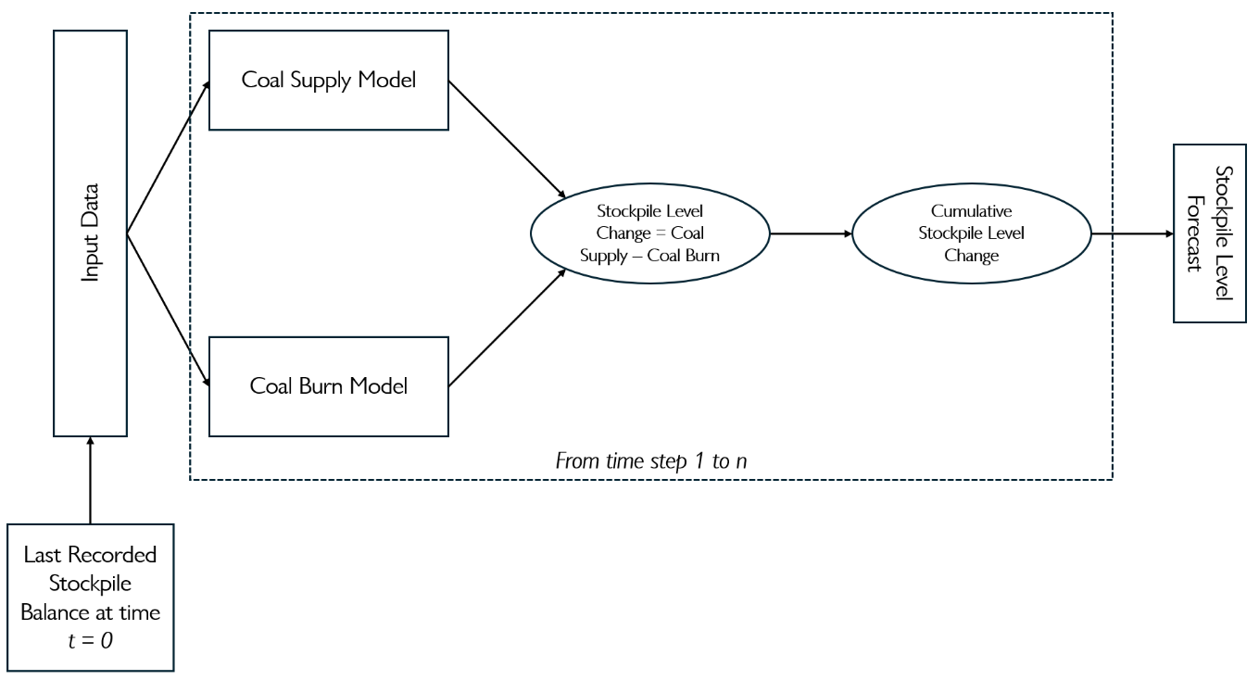
The model will produce Stockpile Level forecasts as follows:
- Input data will be fed into the Coal Supply Model and the Coal Burn Model.
- The Coal Supply Model and Coal Burn Model will produce forecasts of the Coal Supply and the Coal Burn respectively.
- The Stockpile Level Change is calculated by subtracting the Coal Burn forecasts from the Coal Supply forecasts. A cumulative sum of the Stockpile Level Changes is then calculated.
- The Stockpile Level Forecast is then calculated by adding the Last Recorded Stockpile Balance at time t = 0 to the cumulative sum of the Stockpile Level Changes calculated in the previous step.
The modelling approach above will be followed to produce Coal Stockpile Forecasts for the following timeframes:
- 1 year ahead:
  - 31 to 90 days in advance
  - 91 to 365 days in advance.
- 2 years ahead:
  - 1 to 2 years in advance
- 3 years ahead:
  - 2 to 3 years in advance
The forecasting timeframes are shown below.
Current Day | 1 year ahead |  |  | 2 years ahead | 3 years ahead
Current Day |  | 31-to-90-day forecasts | 91-to-365-day forecasts | 1-year forecasts | 2-year forecasts

For example, if the current date is 31 March 2024, the forecasts would be as follows:
Current Date | 1 year ahead |  |  | 2 years ahead | 3 years ahead
31 Mar 2024 |  | 1 May 2024 – 29 Jun 2024 | 30 Jun 2024 - 31 Mar 2025 | 1 Apr 2025 – 31 Mar 2026 | 1 Apr 2026 – 31 Mar 2027

7.2 Type of Machine Learning Models and Training Frequency
The machine learning models to be implemented for forecasting coal supply and burn at Eskom’s power stations will be chosen from the following models, with the goal of selecting the most appropriate one based on data characteristics, model performance, and interpretability:
Model | Advantages | Disadvantages
Linear Regression  A basic regression model that fits a straight line through data by minimizing the difference between predicted and actual values. | - Simple, interpretable, and fast to train  - Useful for datasets with linear relationships | - Assumes a linear relationship between features and target  - Sensitive to outliers and multicollinearity
Decision Tree  A non-linear model that splits data into branches based on feature values to make predictions. | - Easy to interpret and visualize  - Captures non-linear relationships  - Handles both numerical and categorical data | - Prone to overfitting, especially on noisy data  - Can be unstable with small data changes
Support Vector Machine (SVM)  A model that finds the best hyperplane for regression by minimizing errors within a margin defined by the user. | - Effective in high-dimensional spaces  - Can handle non-linear relationships using kernel functions | - Computationally expensive for large datasets  - Requires careful parameter tuning
AutoRegressive Integrated Moving Average (ARIMA)  A time series forecasting model that combines autoregression (AR), differencing (I), and moving averages (MA) to make predictions. | - Effective for stationary time series without seasonal patterns  - Provides good interpretability | - Assumes linearity and stationarity  - Requires extensive parameter tuning and differencing
Seasonal ARIMA (SARIMA)  An extension of ARIMA that includes seasonal components to handle time series with seasonal patterns. | - Captures both seasonal and non-seasonal patterns  - Suitable for periodic time series data | - More complex and requires additional parameter tuning  - Assumes stationarity after differencing
Prophet  A robust time series forecasting tool developed by Meta that handles missing data, outliers, seasonal effects, and holidays. | - Minimal parameter tuning required  - Handles complex seasonal patterns and external events | - Limited flexibility compared to advanced machine learning models such as the models below.  - Assumes additive seasonal effects (e.g. trend + seasonal + residuals) by default, making it unsuitable for capturing multiplicative seasonal effects (e.g. trend x seasonal x residuals). Log transforms may be required if multiplicative seasonal effects are present.
Random Forest  An ensemble of decision trees where each tree is built on a random subset of features and data, and predictions are averaged. | - Reduces overfitting and improves generalization  - Robust to outliers and noise  - Works well with large datasets | - Less interpretable than individual decision trees  - Computationally expensive and memory-intensive
Adaptive Boosting (Adaboost)  A boosting algorithm that combines multiple weak learners by iteratively assigning higher weights to misclassified instances. | - Can achieve high accuracy with fewer weak learners  - Reduces bias and variance | - Sensitive to noisy data and outliers  - Computationally expensive for large datasets
Gradient Boosting Machine (GBM)  A boosting algorithm that builds decision trees sequentially, where each tree corrects the errors of the previous one by minimizing a loss function. | - High prediction accuracy  - Effective at capturing complex relationships | - Computationally expensive and prone to overfitting without regularization  - Requires careful hyperparameter tuning
Extreme Gradient Boosting (XGBoost)  An optimized implementation of gradient boosting with features for handling sparse data, regularization, and efficient training. | - Fast training and high accuracy  - Built-in regularization to prevent overfitting | - Can be memory-intensive for large datasets  - Complex to fine-tune hyperparameters
Light Gradient Boosting Machine (LightGBM)  A gradient boosting framework that uses leaf-wise growth for faster training and better performance on large datasets. | - Extremely fast and efficient for large datasets  - Handles high-dimensional data well | - Sensitive to outliers  - May overfit on small datasets
Artificial Neural Network (ANN)  A biologically inspired model consisting of layers of interconnected nodes (neurons) that learn complex, non-linear patterns. | - Can capture highly complex and non-linear relationships  - Suitable for large and complex datasets | - Computationally expensive and time-consuming to train  - Less interpretable compared to traditional models
Ensemble Model*  A combination of multiple base models to improve prediction accuracy by leveraging their strengths and compensating for weaknesses. | - Often achieves better accuracy than individual models  - Reduces overfitting and variance | - Can be computationally expensive  - Less interpretable than individual models
Stacked Model*  An ensemble approach where multiple base models are combined, and a meta-model is trained to make the final prediction based on their outputs. | - Can significantly improve prediction accuracy  - Utilises the strengths of different models | - Complex to implement and train  - Computationally expensive and prone to overfitting
* Ensemble/Stacked models may be more beneficial as they leverage the strengths of multiple models (simple or complex) and may lead to more accurate predictions.
Training Frequency
The model will be updated with new data at fixed intervals that are yet to be determined to incorporate the latest coal supply, coal burns, market conditions, and other relevant factors. Model retraining may occur more frequently if model performance or external factors suggest the need for adjustments.
This wide array of model options will allow for flexibility in choosing the best approach based on initial experiments, data characteristics, and performance evaluations.

7.3 Performance Metrics
The model’s performance will be assessed using the following regression-specific metrics:
- Root Mean Squared Error (RMSE): RMSE is a key metric for evaluating how far the predicted coal supply and burn quantities deviate from the actual values. It penalizes larger errors more than smaller ones, providing a clear measure of the magnitude of prediction errors.
- Mean Absolute Error (MAE): MAE is another commonly used metric, which calculates the average magnitude of the errors in the predictions, without considering their direction (positive or negative). It is easier to interpret compared to RMSE and provides a straightforward assessment of model accuracy.
These metrics will help gauge the model’s ability to accurately predict coal stock levels and will be instrumental in evaluating its effectiveness for Eskom's needs.

7.4 Retraining Triggers
The machine learning model will undergo regular monitoring to ensure its performance remains optimal and accurate over time. Retraining of the model will be triggered under the following conditions:
- Performance Degradation: If key performance metrics such as RMSE, MAE, or SMAPE fall below predefined thresholds, indicating that the model's predictive accuracy has declined, retraining will be required. This could be triggered by a shift in data patterns or the model’s inability to adapt to new dynamics in the coal supply chain.
- Data Drift: Significant changes in the underlying data, such as variations in coal supply, coal burns, or external factors like coal prices, exchange rates, or weather conditions, will prompt a re-evaluation of the model. If new data indicates the model no longer captures the relationships in the data effectively, retraining will be needed.
- Operational Changes: Changes in Eskom’s operational processes, such as shifts in coal procurement, transportation, or storage practices, or the introduction of new power stations, will necessitate model updates to ensure it reflects the new operational realities.
- External Events: Major disruptions in the coal supply chain (e.g., weather events, geopolitical changes, or market price fluctuations) could cause significant changes in the coal stock dynamics. If such events result in noticeable prediction errors, the model will need to be retrained to accommodate these new patterns.
- Model Comparison: As new models are tested (e.g., Decision Tree, Random Forest, Gradient Boosting, or Neural Networks), performance comparisons between models such as Linear Regression, ARIMA, SARIMA, and Prophet may trigger retraining of the model. If one model outperforms others in forecasting accuracy or interpretability, it will replace the previous model.

Model Monitoring
Continuous monitoring tools will track the performance of the model, including real-time tracking of prediction errors and deviations from actual coal stock levels. Alerts will be set up for abnormal performance, ensuring that retraining is initiated in a timely manner.

7.5 Explainability Requirements
Given the importance of the model’s predictions for critical decision-making, the explainability of the machine learning model will be a top priority. The model will need to provide clear, interpretable insights into how predictions are made and what factors influence those predictions. The following explainability requirements will be emphasized:
- Feature Importance: The model will identify and explain which input variables (e.g., coal supply rates, weather conditions, market prices, or coal burns) are most influential in determining the coal stock forecasts. This can be achieved through techniques such as feature importance scores for tree-based models (e.g., Random Forest, Gradient Boosting) or coefficient interpretation for linear models like Linear Regression.
- Model Transparency: Where possible, simpler models such as Linear Regression, Decision Trees, or Prophet will be favoured for their inherent transparency and ease of interpretation. For more complex models like Neural Networks and Gradient Boosting methods (XGBoost, LightGBM), techniques like SHAP (SHapley Additive exPlanations) values or Counterfactuals will be used to provide detailed explanations for individual predictions.
- Visualisation of Predictions: Visualisations will be generated to show how changes in key input features impact predictions of coal stock levels. For instance, partial dependence plots for tree-based models or linear plots for regression models can be used to highlight feature interactions. Additionally, historical prediction vs. actual plots will help assess model performance over time.
- Local Interpretability: For each prediction (e.g., for a specific power station), the model will provide an explanation of how individual features contributed to the forecasted coal stock level. This will ensure that decision-makers can understand why certain predictions were made and the factors that played the most significant role.
- Model Agnostic Techniques: In cases where more complex models (e.g., Neural Networks, SVM, or Random Forest) are used, model-agnostic techniques like LIME or SHAP will be employed to explain model decisions. These techniques provide insights into individual predictions, enhancing trust in the model, especially for stakeholders who may not have technical expertise.
By implementing these explainability features, Eskom will have confidence in using the machine learning model to guide decisions on coal supply and stockpile management, with full transparency into how the model arrives at its predictions.

8. Monitoring and Maintenance Requirements
Effective monitoring and maintenance of the machine learning model are crucial for ensuring the model continues to perform accurately and efficiently over time. The following subsections outline the key monitoring, logging, and post-deployment maintenance requirements.

8.1 Model Monitoring
To ensure the continued accuracy and reliability of the model, continuous monitoring will be implemented, focusing on the following aspects:

Data Drift Detection
Data drift occurs when the statistical properties of the input data change over time, which may lead to a decline in model performance. Continuous monitoring will be employed to detect any shifts in input data distributions. If data drift is detected, the system will trigger an alert for further investigation, ensuring the model remains aligned with current conditions. Key indicators of data drift will include:
- Changes in the distribution of input features such as coal supply quantities, coal burns, and external factors (e.g., market prices, weather conditions).
- Significant shifts in relationships between features and the target variable (coal stock levels).

Performance Degradation Alerts
Performance degradation occurs when the model’s prediction accuracy decreases due to factors such as changes in data patterns or external influences. To ensure the model is performing as expected, the following metrics will be monitored:
- RMSE, MAE, R², and other relevant performance metrics.
- If the model’s performance falls below a predefined threshold (e.g., a 5% increase in RMSE or MAE), an alert will be triggered for model evaluation and potential retraining.
- Automated performance monitoring systems will continuously track these metrics, ensuring that any degradation is promptly identified and addressed.

8.2 Logging and Alerting
Effective logging and alerting systems will be set up to capture all key events and system activities, facilitating audits, troubleshooting, and proactive model management:

Logging for Audits and Troubleshooting
All model interactions, predictions, data inputs, and system actions will be logged for auditing purposes. This will provide transparency into the model’s behaviour, allowing for easy tracing of issues. The logs will capture:
- Input features and corresponding predictions (coal stock levels) for each run.
- Any changes made to the model, including retraining activities and model parameter adjustments.
- Performance metrics and error logs for each prediction batch.
- Instances of data drift or performance degradation triggers.
These logs will be stored in a secure and easily accessible location, enabling efficient troubleshooting and audits by both technical teams and stakeholders.

Thresholds and Notification Systems
A threshold-based alerting system will be set up to notify relevant stakeholders (e.g., data scientists, engineers, and PED managers) if any critical events occur. These events may include:
- Data drift exceeding predefined limits.
- Model performance degradation beyond acceptable thresholds (e.g., a significant increase in RMSE or MAE).
- System errors or failures during model prediction, retraining, or deployment. Notifications will be sent via email, SMS, or an internal messaging platform, ensuring that the appropriate team members can respond quickly to potential issues.

8.3 Post-Deployment Maintenance
Once the model has been deployed, ongoing maintenance will be essential to ensure its long-term effectiveness. The following activities will be carried out as part of post-deployment maintenance:

Retraining Schedule
To maintain the model's accuracy and relevance, a monthly retraining schedule will be followed. However, if data drift or performance degradation triggers occur, the model will be retrained sooner. This schedule will include:
- Regular updates to incorporate the latest data on coal supply, coal burns, market conditions, and external factors such as weather and geopolitical influences.
- Continuous evaluation of model performance against established metrics to decide whether retraining is necessary.

Error Handling Protocols
In the event of an error (e.g., prediction failure, data inconsistency, or model crash), the following error handling protocols will be in place:
- Automated Error Detection: The system will automatically detect failures during the prediction process, model retraining, or data preprocessing.
- Error Logging: Detailed error logs will capture the nature of the failure, including any input data anomalies, system malfunctions, or other issues that may arise.
- Error Notification: The system will send alerts to technical teams for immediate attention. Critical errors will prompt an investigation, and the model will be suspended from use, if necessary, until the issue is resolved.
- Fallback Mechanisms: In the event of a system failure or severe model error, a fallback mechanism will be in place to ensure that the previous version of the model or a basic fallback model (such as Linear Regression or ARIMA) is used until the issue is resolved.

By implementing robust monitoring, logging, alerting, and maintenance protocols, the machine learning model will remain reliable, accurate, and aligned with the operational needs of Eskom's coal stockpile management system over time.

9. Usability Requirements

9.1 User Training and Documentation
To ensure smooth adoption and proper usage of the machine learning model, comprehensive user training and documentation will be provided to relevant stakeholders. This will include:
- Training Sessions: Training programs will be designed for end users. These sessions will cover:
  - Understanding how to interpret the model’s outputs (e.g., coal stock forecasts).
  - Key performance metrics (e.g., RMSE, MAE) and how to use them for decision-making.
  - Instructions on interacting with the model’s interface, including how to input data, trigger predictions, and access reports.
  - Best practices for monitoring model performance and identifying when retraining or adjustments are needed.
- User Manuals and Guides: Detailed user manuals will be provided, including:
  - Step-by-step instructions on how to interact with the model and the reporting dashboards.
  - Troubleshooting guides for common issues.
  - Clear explanations of key concepts, such as how the model predicts coal stock levels and how external factors (e.g., weather, market prices) are accounted for.
  - Glossary of terms used in the model and outputs (e.g., ARIMA, RMSE, data drift).
The following training sessions schedule is suggested:
Functionality |  | In person |  |  |  |  | Online
 |  | Week 1 | Week 2 | Week 3 | Week 4 | Week 5 | Week 6 | Week 7 | Week 8
1 | General Layout Overview
2 | Landing Page Walkthrough
3 | Planning Insights & Analytics
4 | Scenario Simulation & Management
5 | Model Health Tracking
6 | Data History Visualisation
7 | AI Report Generation
8 | Q&A and Check Up, Buffer

